**A Comprehensive Analysis of MEV: What is MEV and How to Execute It?**

In the blockchain space, MEV (Miner Extractable Value, or Maximal Extractable Value in Proof-of-Stake systems) refers to the extra profit that block producers (such as miners in Proof-of-Work or validators in Proof-of-Stake) can extract by manipulating the order of transactions within a block, excluding specific transactions, or directly altering transactions. This behavior can not only affect the fairness and decentralization of the blockchain network but also create significant financial opportunities for individuals or teams with advanced technical skills.

## **1. How MEV Works**

In a blockchain, whenever a transaction is submitted to the network, it first enters the memxpool (a temporary space where pending transactions are stored). Block producers are responsible for selecting transactions from the mempool and packing them into new blocks. Typically, transactions are ordered by the fees they pay, with higher-fee transactions being prioritized for confirmation.

However, some block producers can exploit their control over transaction order to reorder transactions and extract additional profit. For instance, in front-running, block producers can insert their own transactions ahead of high-value transactions that are about to be executed, thereby capturing arbitrage profits.

## **2. The Economics of MEV: Understanding the Supply Chain**

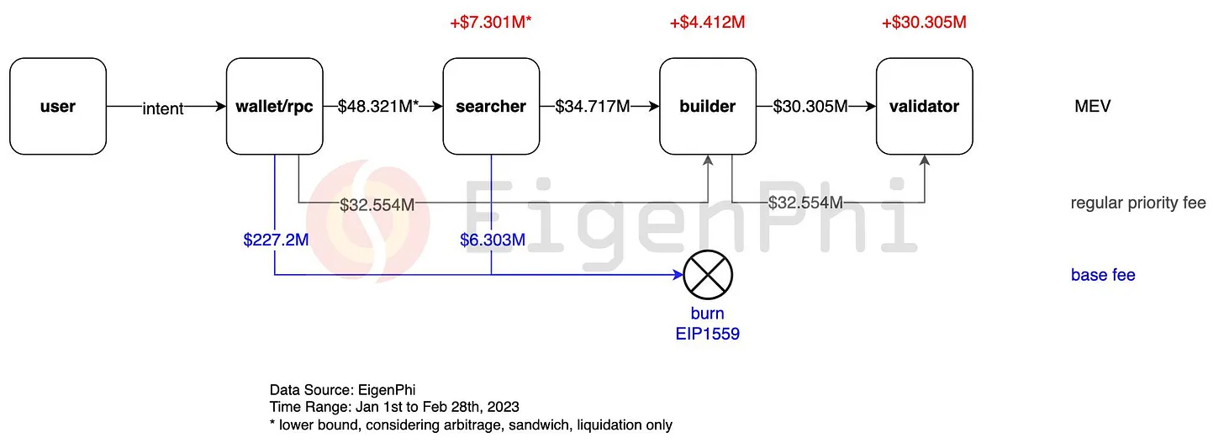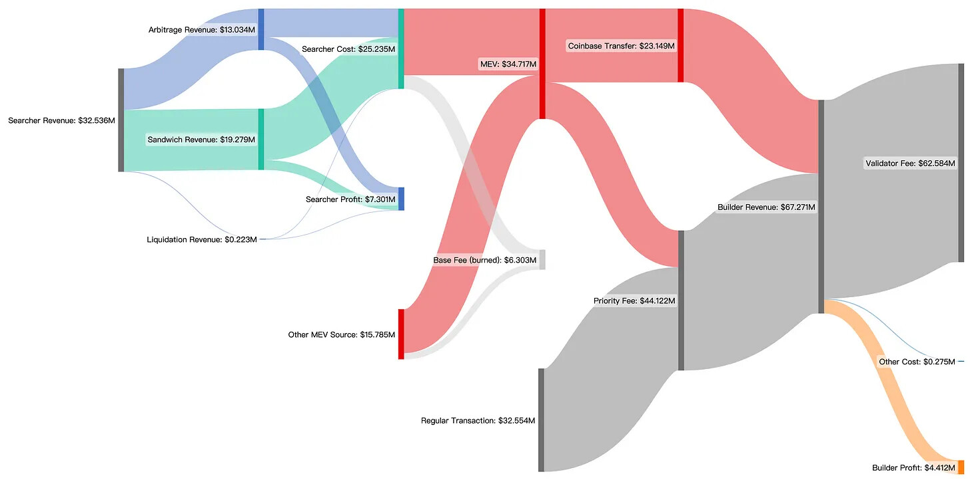Recent data from January and February 2023 illustrates the complexity and profitability of the MEV supply chain. During this period, MEV searchers extracted a total of $48.3 million from user transactions via wallets and RPCs, with $34.7 million of this amount going to builders, and $30.3 million being passed on to validators.

A significant portion of the $48.3 million, specifically $6.3 million, was burnt due to the EIP 1559 mechanism. The remaining funds were distributed as follows: MEV searchers retained $7.3 million, builders netted $4.4 million, and validators, the top beneficiaries, took home $30.3 million. This distribution highlights the substantial impact MEV has on the financial dynamics within blockchain networks.

## **3. Common MEV Strategies**

**Front-Running:** When an MEV bot detects a profitable transaction about to be included in a block, it immediately submits a similar transaction but with a higher fee, ensuring that its transaction is executed first. This technique can be used to purchase assets at a low price on decentralized exchanges (DEXs).

**Sandwich Attack:** This variation of front-running involves placing buy and sell orders before and after a target transaction, manipulating asset prices, and earning a profit in a short timeframe. This strategy is particularly effective for large trades, which often significantly impact market prices.

**Arbitrage Trading:** Block producers exploit price differences between decentralized exchanges by buying low on one exchange and selling high on another. For instance, when a token has a price discrepancy between two exchanges, an MEV bot can buy the token on the cheaper exchange and sell it on the more expensive one.

**DeFi Liquidations:** On DeFi lending platforms, if the value of a borrower’s collateral drops below a certain threshold, the collateral is forcibly liquidated. MEV bots prioritize executing these liquidation transactions to earn a profit.

## **4. MEV’s Impact on Block Producers: Builders and Validators as Key Players**

The data also reveals that MEV accounts for 51.6% of builders' revenue, with the remaining 48.4% coming from priority fees paid by regular transactions. Despite builders generating $67.3 million in revenue during the first two months of 2023, 93% of this was allocated towards bidding in relay auctions to compensate validators, ensuring that the validators would eventually propose the blocks.

The concentration of profits is notable. Lido, for instance, captured about 30% of the MEV market share, reflecting its dominance as both a builder and validator. This oligopoly effect is significant, as the top three players secured approximately 50% of the total profits, further centralizing the MEV landscape.

## **5. Risks and Impacts of MEV**

While MEV can bring additional profits to block producers, it also poses potential risks and negative impacts on blockchain networks. First, MEV can lead to unfair transaction ordering, undermining the transparency and trustworthiness of the blockchain. Second, because of the high technical barriers, some miners or validators have an advantage over others, leading to network centralization.

Moreover, when many participants compete for MEV opportunities simultaneously, it can cause network congestion and skyrocketing transaction fees, further harming network efficiency and user experience. In some DeFi ecosystems, MEV has almost become a hidden tax, increasing the transaction costs for all users.

## **6. How to Execute MEV Strategies**

Executing MEV strategies typically requires advanced technical tools, such as MEV bots or specialized analysis software. These tools can monitor transactions in the mempool in real-time and automatically identify and execute profitable trading strategies. Here are some specific steps for executing MEV:

**Deploy MEV Bots:** These bots can automatically scan the mempool and filter out potential profitable transactions based on preset algorithms and strategies.

**Set Up Front-Running Transactions:** When a bot detects a profitable transaction, it sends a similar transaction with a higher fee to ensure its transaction is executed first.

**Monitor Market Movements:** MEV bots are usually connected to price information systems across multiple decentralized exchanges, monitoring market price fluctuations in real-time and quickly executing arbitrage trades when price discrepancies arise.

**Automate Liquidations and Asset Transfers:** On DeFi lending platforms, bots can automatically monitor collateral value changes and prioritize executing liquidation transactions when conditions are met.

## **7. Strategies to Mitigate MEV**

Blockchain developers and community members have proposed several methods to reduce the risks of MEV. For example, using privacy technologies (like zero-knowledge proofs) to hide transaction details, or introducing more complex smart contract languages to reduce vulnerabilities. Additionally, some blockchains, like Bitcoin, choose to keep smart contract functionality simple to limit the occurrence of MEV.

## **8. Conclusion**

MEV is a phenomenon that cannot be ignored. While it presents potential profit opportunities for block producers, it also poses challenges to the fairness, decentralization, and user experience of blockchain networks. Understanding and mitigating the risks of MEV is crucial for the sustainable development of blockchain technology. As blockchain technology continues to evolve, the ongoing challenge will be how to enhance the expressive power of smart contracts while minimizing the risks associated with MEV.